

**STANDARD OPERATING PROCEDURE**

**Do not Photocopy**

**Document Information Classification: Unrestricted**

|  |  |
| --- | --- |
| **Title:** | **Managing Training** |
| **Effective Date:** | **16 Aug 2019** |
| **Reference Number:** | **SOP-01-02** |
| **Version Number:** | **3.0** |
| **Owner:** | **Training and Competency Process Owner,** |
| **Review Date:** | **16 Aug 2021** |

Table of Contents

1. Purpose 3

2. Scope 3

3. Responsibilities 3

4. Procedure 3

4.1. Training Requirements 3

4.2. Assigning Individuals to Training Events 4

4.3. Training Completion 4

4.4. Managing Feedback 4

5. Cross-referenced ISMS Documents 4

6. Appendices 4

6.1. Guidelines for Managing Training Records in Q-Pulse 4

6.1.1. Training Record Hierarchy 4

6.1.2. Creating a Master Event 5

6.1.3. Creating a Master Competency 6

6.1.4. Adding a Competency to a Person Record 8

6.1.5. Scheduling Training Through the Training Module 8

6.1.5.1. Adding Attendees to a Training Event 9

6.1.5.2. Completing the Training Event Record 10

6.1.6. Completing Training Records 11

1. Purpose

All employees of the organization and, where relevant, contractors should receive appropriate awareness education and training and regular updates in organizational policies and procedures, as relevant for their job function.

This SOP describes how training should be planned, communicated and recorded.

1. Scope

All training that is required for compliance with the ISMS by CHI staff and students.

1. Responsibilities

The ISMS Training and Competency Process Owner is responsible for:

* Organising training events
* Inviting trainees to training events
* Monitoring training data and feedback
* Maintaining training records on Q-Pulse

Line Managers are responsible for:

* Ensuring their reportees are made available to attend training events
* Communicating training needs to the ISMS Training and Competency Process Owner

Trainees are responsible for:

* Responding to or actioning alerts about training requirements
* Attending scheduled training
* Ensuring target dates are agreed with their line manager
* Providing feedback for on-site training events when requested
* Informing staff trainers of other training events attended and provide documentary evidence

1. Procedure
   1. Training Requirements

The requirement for training will usually be driven by one of the following:

* Induction training required by the university or CHI
* Training to access the TRE
* Refresher/update for training already completed
* Request from individual or their line manager

Examples of mandatory training include:

* Induction
* Use of Q-Pulse
* Data Protection Training
* Research data confidentiality training (TRE users only)
  1. Assigning Individuals to Training Events

The ISMS Training and Competency Process Owner will assign individuals to the training courses or events to meet the mandatory requirements for training of CHI staff and students. This will include a target date by when the training is expected to be complete.

Where training courses or events have been organised or arranged by CHI the ISMS Training and Competency Process Owner will ensure that invitations are sent to all proposed trainees who will confirm their availability to attend.

* 1. Training Completion

On successful completion of training the trainee, line manager or course manager, as appropriate, will inform the ISMS Training and Competency Process Owner who will update the details of the completion date to the person’s training record in Q-Pulse.

Individuals that do not complete mandatory training when reminded, or do not attend scheduled training without good reason may have access to systems removed and face disciplinary action ([UoM Disciplinary Procedure](http://documents.manchester.ac.uk/display.aspx?DocID=480)).

Where appropriate supporting documents may be attached to the person record in Q-Pulse to provide the necessary evidence of the training e.g. complete New Starter Induction Checklist (FORM-004)

* 1. Managing Feedback

Training feedback can be given on all internally provided training sessions to assist with their development. This will be requested from trainees, where relevant, by email and will be monitored by the ISMS Training and Competency process owner.

1. Cross-referenced ISMS Documents

|  |  |  |
| --- | --- | --- |
| Number | Type | Title |
| FORM-004 | ISMS\Forms | New starter and leaver asset and IT account checklist |
| SOP-01-01 | ISMS\SOP\Personnel & Training - SOP | Induction of new staff and students |

1. Appendices
   1. Guidelines for Managing Training Records in Q-Pulse

This section is only applicable to users with access to the training module.

* + 1. Training Record Hierarchy

Training records in Q-Pulse are created in two levels that should be linked together.

The lowest level is a **Master Event**. A Master Event is a training session where training is conducted and trainees attend and can give feedback. They can be renewable or one-off events.

The next level is **Master Competencies**. A competency describes a skill or knowledge that a user should have in order to perform their role, e.g. Q-Pulse Administrator or Staff Induction. Training Requirements can then be assigned to a Master Competency. The training requirements for these competencies will be taken from the Master Event list.

* + 1. Creating a Master Event

All general training requirements will be included into the master event list. To create a new training event (Master Event):

* Access the People module
* Click Edit -> Master Event List
* Click New -> Master Event list

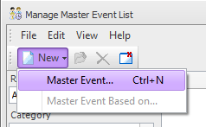

* This will display the Master Event Details form

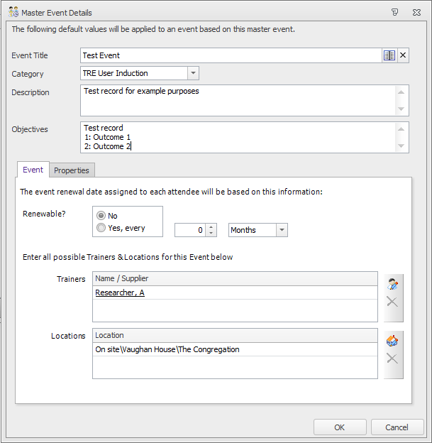

* The fields should be completed as follows::
  + **Title** - Enter a title for the training event.
  + **Category.** For mandatory events select “Mandatory”.
  + **Description** - Enter the description of the event and list the event objectives.
  + **Renewable?** - Select if the event is a renewable event (i.e. is it a one-off training event or is it to be renewed after a set period) If it is renewable select the renewal period in years, months or weeks.
  + **Trainers** - Add the names of any trainers (i.e. individuals that are competent to provide training in that subject)
  + **Location** - Select a location for the training (e.g. on site)
* Click OK to save the form.
  + 1. Creating a Master Competency

To create a new master competency:

* Access the People module
* Click on Edit -> Master Competencies
* Click File -> New
* This will display the Master Competency List form

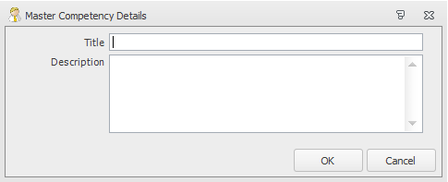

* The field should be completed as follows:
  + **Title** – Enter a title for the master competency
  + **Description** – Enter a description for the competency
* Click OK. This will display the Master Competency List and the new competency will appear in this list.

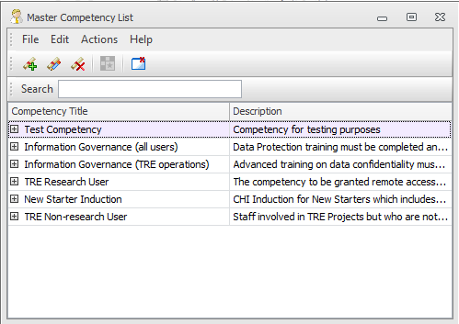

* Double click on the new competency to edit the details. This will allow competency levels and master events to be added the competency.

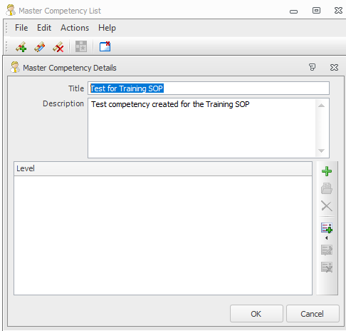

* Click the  icon to add a new level of attainment to the selected competency. This can be a single level e.g. (1) Genera Awareness or multiple levels can be added e.g. Basic training, Trained, Trainer. The levels are selected from a dropdown list.



* For each level, add requirements by selecting clicking the  icon.

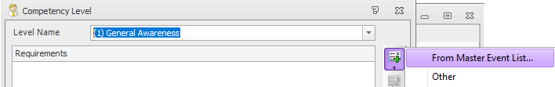

Requirements should be selected from the master events list (e.g. training that must be achieved).

* Click OK to finish adding requirements to the competency.
  + 1. Adding a Competency to a Person Record

The Training Plan can be viewed on the Training tab on a person record.

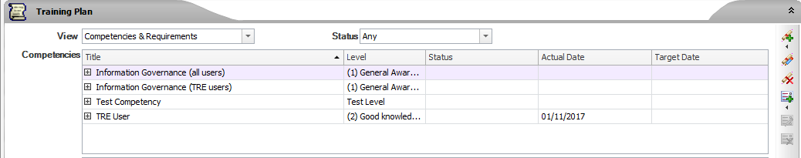

To add a new competency Click on the  icon and select ‘From Master Competency List’. This will display the Master Competency List.

* Select the required competency and click ‘OK’ to add it to the Training Plan.
* This will also add the training events that must be completed.
* Add target dates to the competency and the training events
* Save the person record
  + 1. Scheduling Training Through the Training Module

Training is scheduled via the Training Courses module.

Scheduling a new event:

* Access the Training and Qualifications module
* Select File -> New -> New Event
* This display the New Training Courses form:

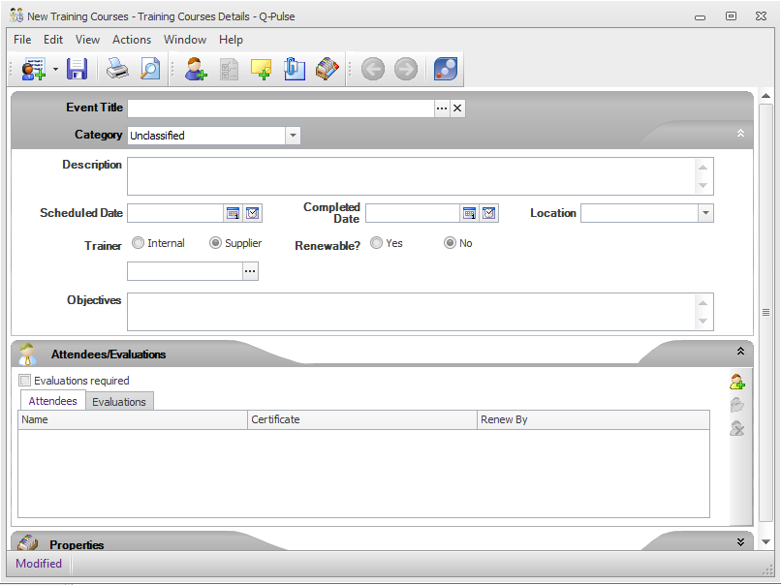

* The fields should be completed as follows:
  + **Event Title -** this can be selected from a list of existing Master Events. If the event does not already exist a new title can be entered
  + **Category**. This will be updated automatically if the event is a master event, otherwise select a value from the drop-down list
  + **Scheduled Date** – the date the event is scheduled (optional)
  + **Completed date** – only to be filled after the event has been held
  + **Description –** Event description (this is automatically completed if a master event has been selected)
  + **Trainer –** the nominated trainer for the event. Must be an existing person or supplier in Q-Pulse (optional)
  + **Objectives –** Course objectives (optional)
  + **Location** – Location for the event (optional)
  + **Attendees list** – Names of the people attending the course.
* Save the record
  + - 1. Adding Attendees to a Training Event
* Click on the  icon to display the ‘Select Attendees’ form

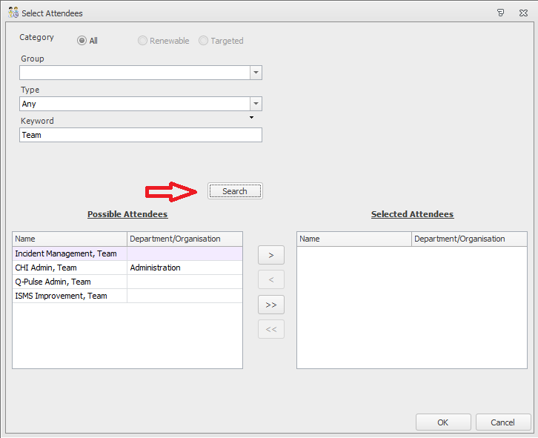

* Click ‘Search’ to list all of the person records
* Select the attendees from the “Possible attendees” list and use the arrows to move them into the “Selected Attendees” list.
* Click OK
* Save the training event record
  + - 1. Completing the Training Event Record

To complete the training event record:

* Access the Training event record card in the training module after the event has been conducted
* Set the completed date as the date the training was held
* Edit the attendee list to confirm the actual attendees. Attendees can be added or removed as required
* Where applicable, add certificates to each user by editing each row of the attendee list. Double click or use the edit icon to access the record and attach a certificate via the ellipsis icon next to the “Certificate” field.
* Click Save.

Training records for all attendees will be automatically updated with the completed event and, if the event was linked to a master event, the training plan will also be updated.

* + 1. Completing Training Records

If training records are not updated through the training courses modules, e.g. for skills or bespoke events they can be completed directly via the Training Plan tab on the person record.

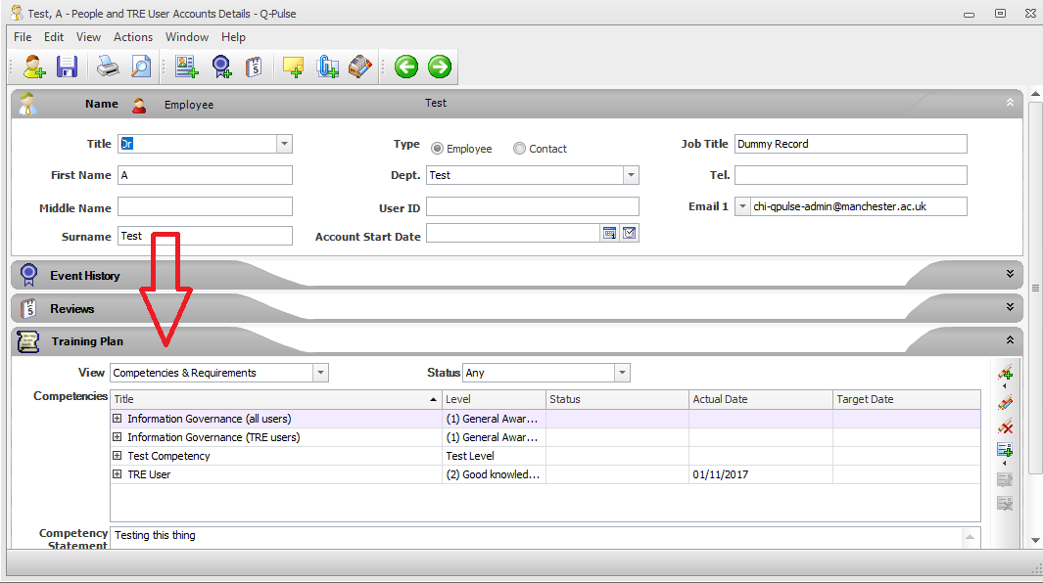

* Double click on the competency to be updated
* Update the “Completed Date” for each requirement

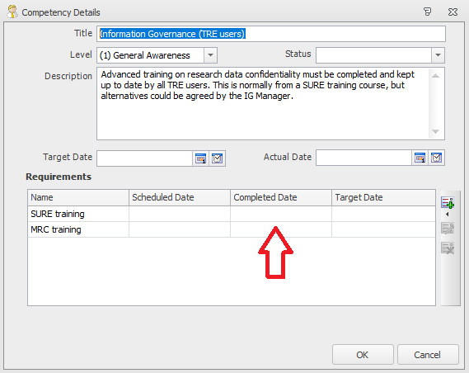

* Update the Competency ‘Status’ field by selecting an option from the dropdown list
* If all requirements are complete for the competency update the “Actual Date” with the date achieved.
* Click OK and Save the person record.